Experiment Title
Basic VLAN Configuration and Verification Using Cisco Switch CLI
Objectives
The objective of this experiment is to understand the concept of Virtual Local Area Networks (VLANs) and their role in logically segmenting a network. This experiment focuses on configuring VLANs on a Cisco switch using the Command Line Interface (CLI) and verifying communication between devices belonging to the same VLAN while ensuring isolation between different VLANs.
System Configuration
Software Platform:
Cisco Packet Tracer (Version 8.x or above)
Operating System:
Windows 11
Network Components:
- One Cisco 2960 Switch
- Four Personal Computers (End Devices)
Cabling Used:
Copper Straight-Through cables (PC to Switch)
Configuration Method:
Cisco Switch Command Line Interface (CLI)
Steps and procedures
Step 1: Placing Devices on Cisco Packet Tracer Workspace
At the beginning of the experiment, a new project was created in Cisco Packet Tracer. One switch and four PCs were placed on the workspace. The devices were arranged properly to represent a small switched network and renamed where necessary for easier identification during configuration.
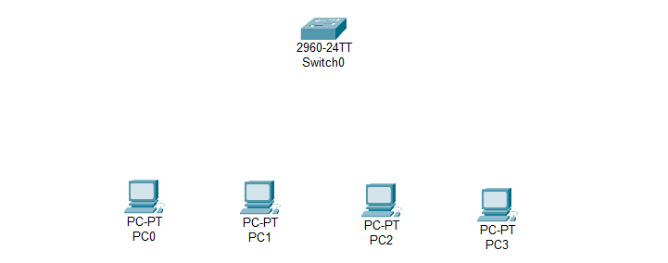
Figure 10.1: Placing all the devices into workspace
Step 2: Connecting Network Devices
Each PC was connected to the switch using copper straight-through cables. Different FastEthernet ports on the switch were used for each PC to allow individual port-based VLAN assignment later in the experiment.
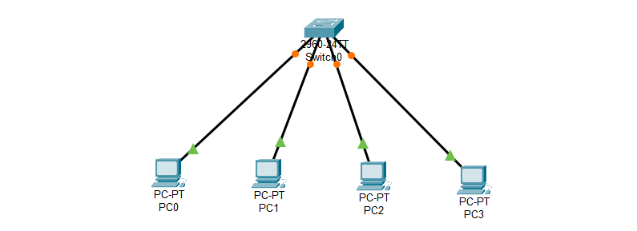
Figure 10.2: Connecting all devices through straight through cable
Step 3: Assigning IP Addresses to all PCs
Static IP addresses were assigned to all PCs. The devices were divided into two separate IP networks so that VLAN-based communication behavior could be observed clearly during testing.
PC IP Address––––––––––Subnet Mask
PC0 192.168.1.2 – 255.255.255.0
PC1 192.168.1.3 – 255.255.255.0
PC2 192.168.3.2 – 255.255.255.0
PC3 192.168.3.4 – 255.255.255.0
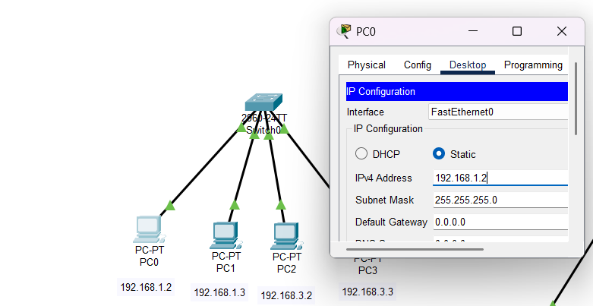
Figure 10.3: Assigning IP Addresses to all PCs
Step 4: Accessing the Switch CLI
The switch’s Command Line Interface was accessed to perform VLAN configuration tasks. Privileged EXEC mode and global configuration mode were entered to allow VLAN creation and port assignment.
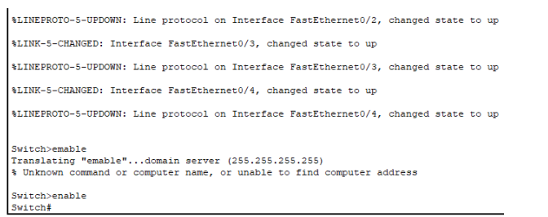
Figure 10.4: Accessing the Switch CLI
Step 5: Creating VLANs
Two VLANs were created on the switch using CLI commands. Each VLAN was assigned a unique VLAN ID and an appropriate name to distinguish between different logical groups within the network.
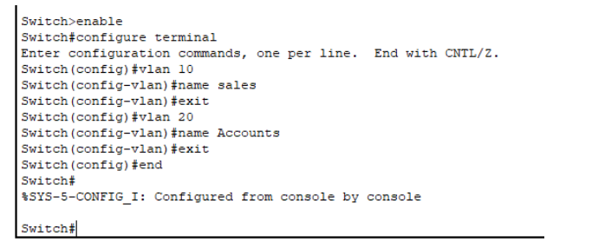
Figure 10.4: Creating VLANs using CLI
Step 6: Assigning Switch Ports to VLANs
Specific FastEthernet ports on the switch were configured as access ports and assigned to the corresponding VLANs. This step ensured that devices connected to those ports became members of their designated VLANs.
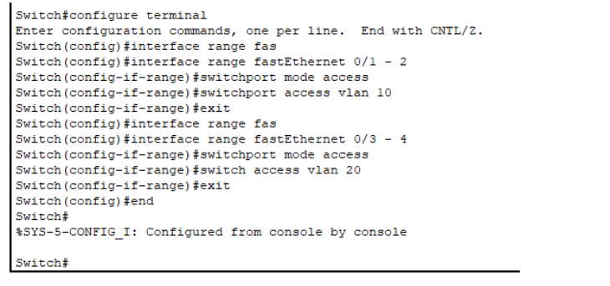
Figure 10.5: Assigning Switch Ports to VLANs
Step 7: Verifying VLAN Configuration
To confirm successful VLAN creation and port assignment, verification commands were executed on the switch. The VLAN summary output displayed all configured VLANs along with their associated switch ports.
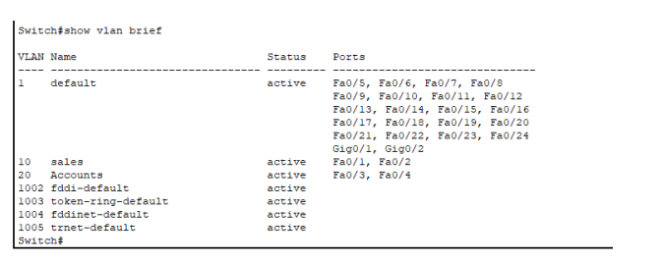
Figure 10.6: VLAN Verification Output
Step 8: Testing VLAN Connectivity
Connectivity tests were performed using the ping command from the PCs. Devices within the same VLAN were able to communicate successfully, while communication attempts between devices in different VLANs failed. This behavior confirmed proper VLAN isolation.
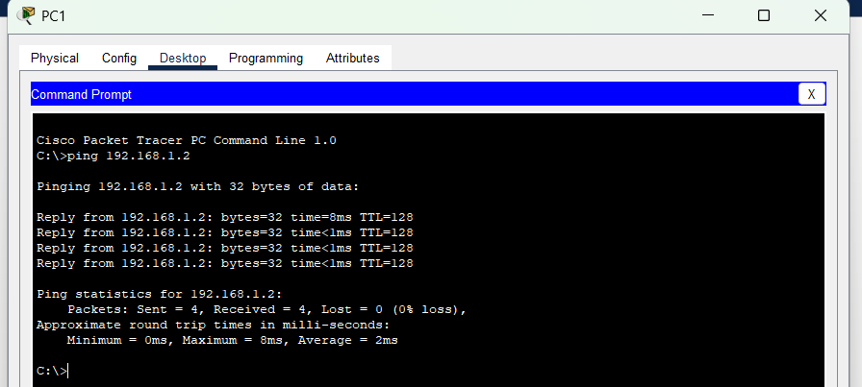
Figure 10.7: VLAN Communication Test Results
Step 9: Saving the Configuration
Finally, the switch configuration was saved to non-volatile memory to ensure that VLAN settings would remain intact after a device restart.
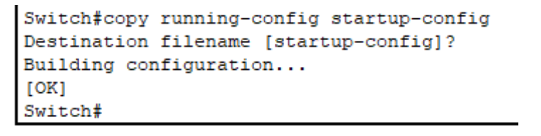
Figure 10.8: Saving VLAN Configuration to NVRAM
Result and Discussion
The experiment successfully demonstrated VLAN configuration using a Cisco switch. VLANs were created and switch ports were correctly assigned, resulting in proper logical segmentation of the network. Devices belonging to the same VLAN communicated without issues, while devices in different VLANs remained isolated. This confirms the effectiveness of VLANs in improving network security, organization, and traffic management.
Conclusion
In this experiment, VLANs were configured using Cisco switch CLI commands to logically divide a single physical network into multiple virtual networks. The results verified that VLANs allow communication only within the same logical group while preventing unnecessary traffic between different groups. This experiment provided a clear practical understanding of VLAN concepts and highlighted their importance in modern switched networks.

